**Required for CI-CD pipeline/flow**

Access (Record track of it via excel/notes)

-Mandatory permissions- for tools- TFS/Azure and shared paths with target servers.

-Resource Needed (VDI, VS, Tools for testing etc.)

**Phase 1 (Need to start in parallel)**

**Project management** (Visible dashboard for updates via TFS)

-WI tracking-associated with code commits/check-ins (help for tracking updates)

-Backlogs/iterations and capacity justify sprints (help in forecasting)

**Version Control Management**

-Proper folder structure (help in further release management and automation) like below.

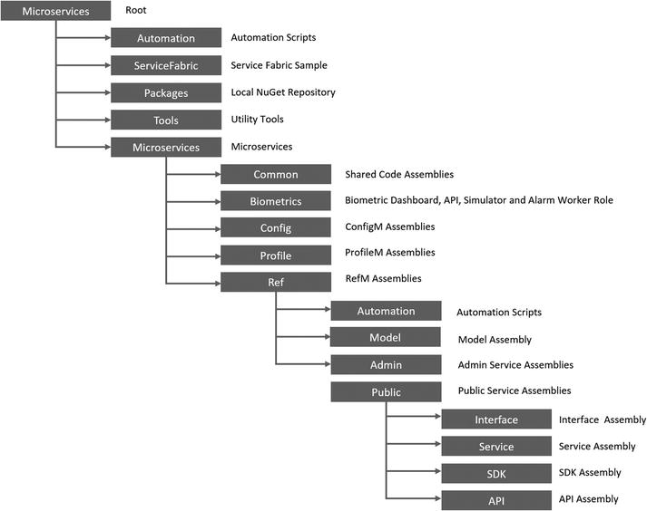

-Check-in policies for associating WI (help in project management)

**Build management** (Mandatorily be regular)

-Build should happen on regular basis (CI/Scheduled or gated check in) irrespective of code changes.

Preferred – Gated check-in.

-Good to have a clean build.

-Separate code Builds and release Builds (needs proper folder structure)

-There should be one release build for all environments.

**Release management**

**-**Should trigger automatically after new build.

**-**Should have approval for promoting to next environments

**Phase 2 (Will start in continuation as one release progress)**

**Automation:**

To promote integration and collaboration of development and operations teams. Teams needs to work together to design and develop the process and the tools that will automate the product development lifecycle. Automation can be applied in the following four primary areas:

**Provisioning**: Provisioning involves planning the cloud resources and creating the automation scripts that will be used to create the cloud environment on demand.

**Build/Test**: Continuous Integration using software tools to merge code updates, compile and integrate software assets, and run automated unit tests.

**Deployment**: Deployment automates the packaging of the software assets and data, deploying them to a staging environment for acceptance testing, and then automating the move from staging to production.

**Management**: Automation of the cloud resource configuration, providing control over scale up, scale down, spin up, spin down, sizing, monitoring, and lifetime.

**Administration**

Best practices needed for controlling and monitoring environment